 | Chapter 6 Decision Support
 | Various inquiries and on-line reports are available within the KFS to provide an immediate picture of the current status of your account(s) as you transact your daily business. Since pending ledger entries are created the moment a document begins the routing process, transactions are immediately available for on-line inquiries. As a KFS user you can select the type of inquiry you wish to view, and the criteria you wish to have displayed in the report.
Topics |  | Balance Inquires 6-103  Available Balances Inquiry 6-103  Balances by Consolidation Inquiry 6-103  Cash Balances Inquiry 6-103  General Ledger Balance Inquiry 6-103  General Ledger Entry Inquiry 6-103  General Ledger Pending Entry Inquiry 6-103  Open Encumbrances Inquiry 6-103  Standard Reports 6-103  Account Status Reports 6-103  Account Transactions Reports 6-103  Consolidated Account Status Reports 6-103  Consolidated Status Reports 6-103  Trial Balance Reports 6-103

Balance Inquiries
Access to the various balance inquiries is found in the Balance Inquiries section in the Main Menu tab. Click the desired inquiry. Enter the appropriate criteria in the lookup screen to view the account balances. From there you can drill down to the next level of detail.

Inquiry Categories
There are seven inquiries available. The following chart summarizes the purpose of each inquiry.
Table 6-1 Balance Inquiries
Inquiry Title | Description
Available Balance | Displays the cumulative balances for an account by object code
Balances by Consolidation | Displays account balances at the summarized consolidation level
Cash Balances | Displays the beginning, year-to-date, and available cash balances for an account
General Ledger Balance | Displays an account’s balances by object
General Ledger Entry | Displays the transaction detail for an account
General Ledger Pending Entry | Displays pending transactions from documents that have been approved or submitted for approval, but have not yet posted to the general ledger
Open Encumbrances | Displays the detail for an account’s open encumbrances

Inquiry Steps
Here are some common steps used by each of the inquiries.

Balance Inquiries Menu Group
Select your desired inquiry from the Balance Inquiries menu group in the Main Menu tab.
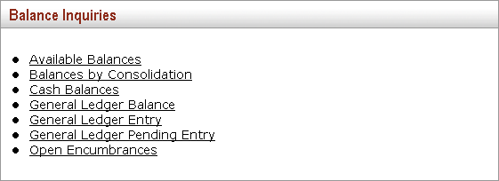
Figure 6-1 Balance Inquiries Menu Group

Lookup Criteria
Once you select the desired inquiry, you are taken to the lookup criteria screen. The lookup criteria may display some default values, which the user may change. To view all general ledger balances on a specific account you need to enter just the chart and the account number. You can be more specific by including additional criteria. If you only wish to view specific sub-accounts, object codes or sub-object codes you may enter these criteria. The balance type may be changed to view something other than Actual balances. For example, if you wish to view Budget transactions, you can change the Balance Type to either CB (current budget), BB (base budget), or MB (monthly budget which may not be available on all accounts).
The following is an example of the lookup criteria screen for the Available Balances inquiry.
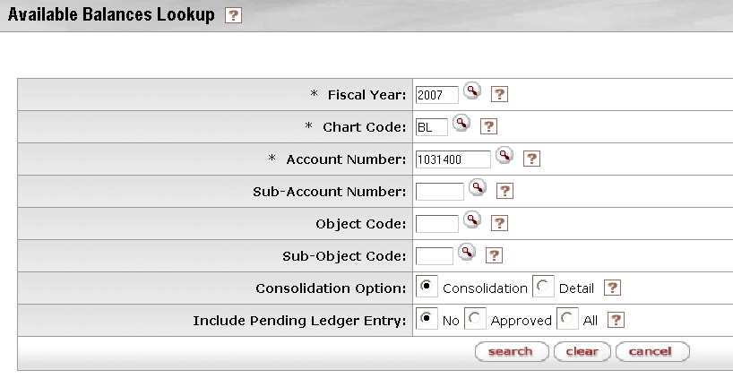
Figure 6-2 Available Balances search criteria example
Click search when you have entered all necessary criteria and are ready to retrieve the balances.

Meaning of Dollar Accumulators
The inquiries contain various dollar accumulators. The following describes the meaning of each of the amounts displayed in the inquiry results, and which inquiries contain the bucket type.
Table 6-2 Dollar Accumulator Definition
Column Title | Description
Account Line Annual Balance Amount | The total amount of activity in this account for this balance type across all periods of the selected fiscal year. Appears in Cash Balances inquiry and the General Ledger Balance inquiry.
Actuals Amount | The total of all actual activity for a given balance line of the selected fiscal year. Appears in Available Balances inquiry and Balances by Consolidation inquiry.
Available Cash Balance | The total of the beginning balance and the year-to-date balance. Appears in the Cash Balances inquiry.
Beginning Balance | The cash balance at the beginning of the current fiscal year. Appears in the Cash Balances inquiry.
Beginning Balance Line Amount | The amount in this account for this balance type at the beginning of the selected fiscal year. Appears in the General Ledger Balance inquiry.
Budget Amount | The current budget amount in this account for the selected fiscal year. Appears in Available Balances inquiry and Balances by Consolidation inquiry.
Closed Amount | The amount of the encumbrance that has been closed. Appears in the Open Encumbrances inquiry.
Contracts Grants Beginning Balance Amount | The cumulative amount in this account for this balance type that was carried forward from the previous fiscal year. Appears in the Cash Balance inquiry and the General Ledger Balance inquiry.
Encumbrances Amount | The total of all encumbrance activity for a given account for the selected fiscal year. Appears in Available Balances inquiry and Balances by Consolidation inquiry.
Ledger Entry Amount | The dollar amount associated with a particular ledger entry. Appears in General Ledger Entry inquiry and Pending General Ledger Entry inquiry.
Open Amount | The amount of the original encumbrance. Subtracting the Closed Amount from the Open Amounts gives the amount of the encumbrance that is still outstanding. Appears in the Open Encumbrances inquiry.
Variance | The difference between the available budget and the actuals, plus encumbrances for an object code or category. Appears in Available Balances inquiry and Balances by Consolidation inquiry.

Drilldown
The various inquiries display their initial balances at different levels of aggregation. You may drill down into detail when there is the Drill Down link available, or if the amount or other attribute (e-doc, for example) is a hyperlink. The following illustrations show the types of drilldowns available in the inquiries.

Drill Down to Next Level Using the Drill Down Hyperlink
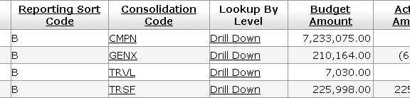
Figure 6-3 You may drill down to the next level from the Drill Down hyperlink.

Drill Down to Entries from an Amount Hyperlink
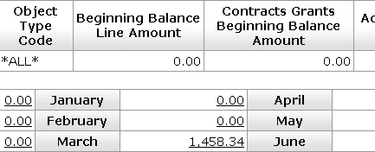
Figure 6-4 You may drill down to the entries that make up the total from the amount hyperlink.

Drill Down to More Details From the Attribute Hyperlink
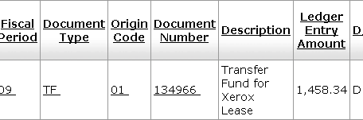
Figure 6-5 You may drill down to a greater level of detail for the attribute; in this example, the actual e-doc from the Document Number link.

Refer to the following chart to determine which inquiry best accomplishes your drilldown purpose.
Table 6-3 Inquiry drill down patterns
 | By  Consoli-  dation | By  Level | By  Object | GL Balance | GL Entry Lookup | By e-doc
Available Balances |  |  |  |  |  | 
Balances by Consolidation |  |  |  |  |  | 
Cash Balances | Lists cash balances only (no drilldown)
GL Balances |  |  |  |  |  | 
GL Entry |  |  |  |  |  | 
GL Pending Entry |  |  |  |  |  | 
Open Encumbrances | Lists open encumbrance amounts only (no drilldown)

Available Balances Inquiry
The Available Balances inquiry displays the cumulative balances for an account by object code. The drilldown pattern is as follows:
1 | General Ledger Balance
2 | GL Entry Lookup
3 | E-Doc

Lookup Criteria
Fill in at least Fiscal Year, Chart Code and Account Number. Use the lookup icon as necessary to select the criteria. Select the desired Consolidation and Included Pending Entry options.
Figure 6-6 Available Balances Search Criteria

Available Balances
The cumulative balances by object code are displayed. You may drill into the amount column to view the details that make up the total amount.
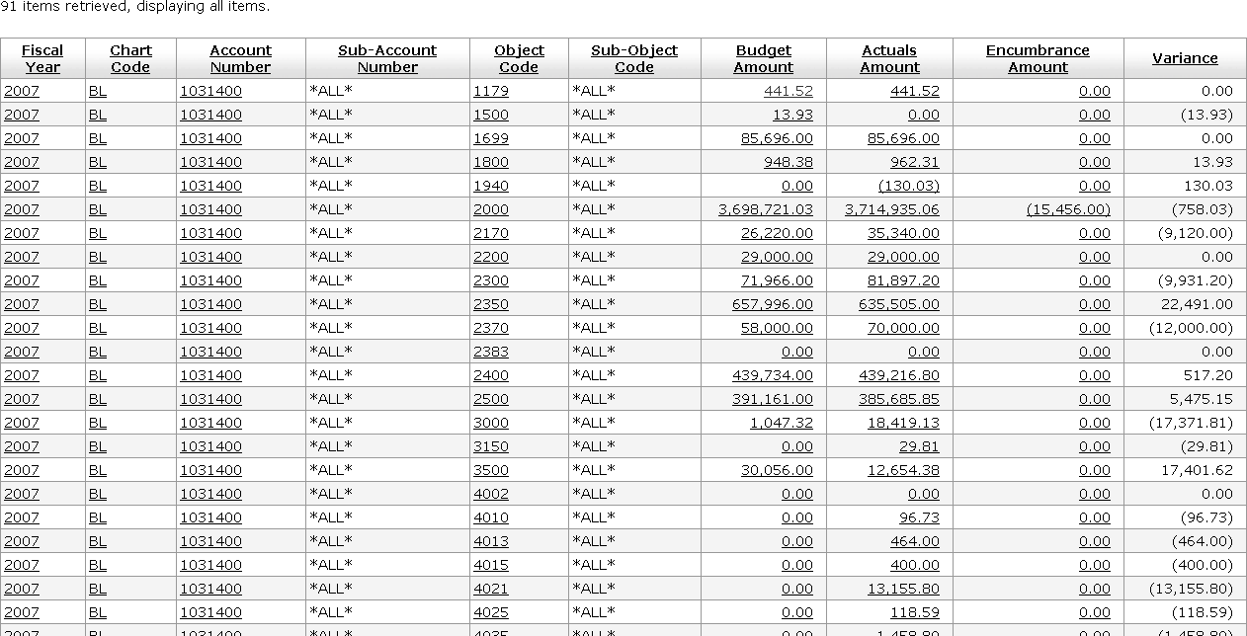
You may click the amount to see the details that make up the total
Figure 6-7 Available Balances Inquiry Result

Balances by Consolidation Inquiry
This inquiry displays account balances at the highest reporting level (the consolidation level) and allows you to drill down to the next reporting level. You can continue this drill down process to arrive at the actual e-doc where the transaction began. You must specify the chart and the account number you wish to view in the report criteria window. The fiscal year defaults to the current fiscal year, but may be changed. You may also include a sub-account if you are interested in that level of detail.
The Consolidation option defaults to display an aggregate total for all sub-accounts for the selected chart and account number. If you select the Detail option, the report displays the balances for each sub-account for the chart and account number selected. The Include Cost Share Sub-Accounts default is to exclude activity on Cost Share sub-accounts. If you wish to view activity on these special sub-accounts select the Include option. The Include Pending Ledger Entry option provides the user with the ability to include all pending entries, no pending entries, or only those pending entries that are fully approved. Cancelled and disapproved pending entries are not pulled into the balance inquiry results.
The drilldown pattern of this inquiry is as follows:
1 | Balances by Consolidation
2 | Balances by Level
3 | Balances by Object
4 | General Ledger Balance
5 | General Ledger Entry
6 | E-Doc

Lookup Criteria
Fill in at least Fiscal Year, Chart Code and Account Number. Use lookup the lookup icon as necessary to select the criteria. Select the desired Consolidation, Include Cost Share Sub-Accounts, and Include Pending Ledger Entry options.
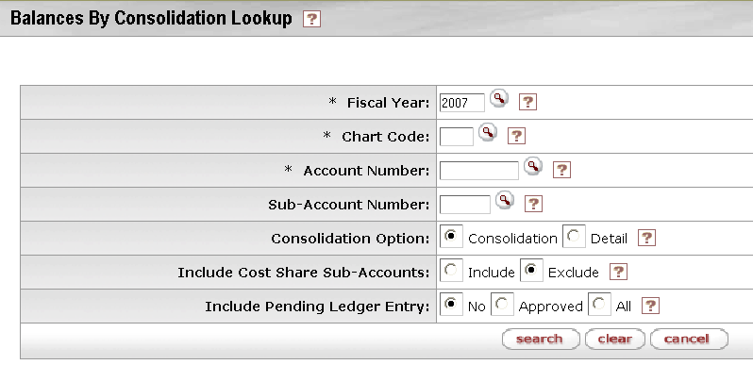
Figure 6-8 Balances by Consolidation Lookup Criteria

Balances by Consolidation
The highest level of summary you see in this inquiry is by account consolidation based on the Consolidation Object levels established by your institution. You may drilldown into the summary by level by clicking the Drill Down link.
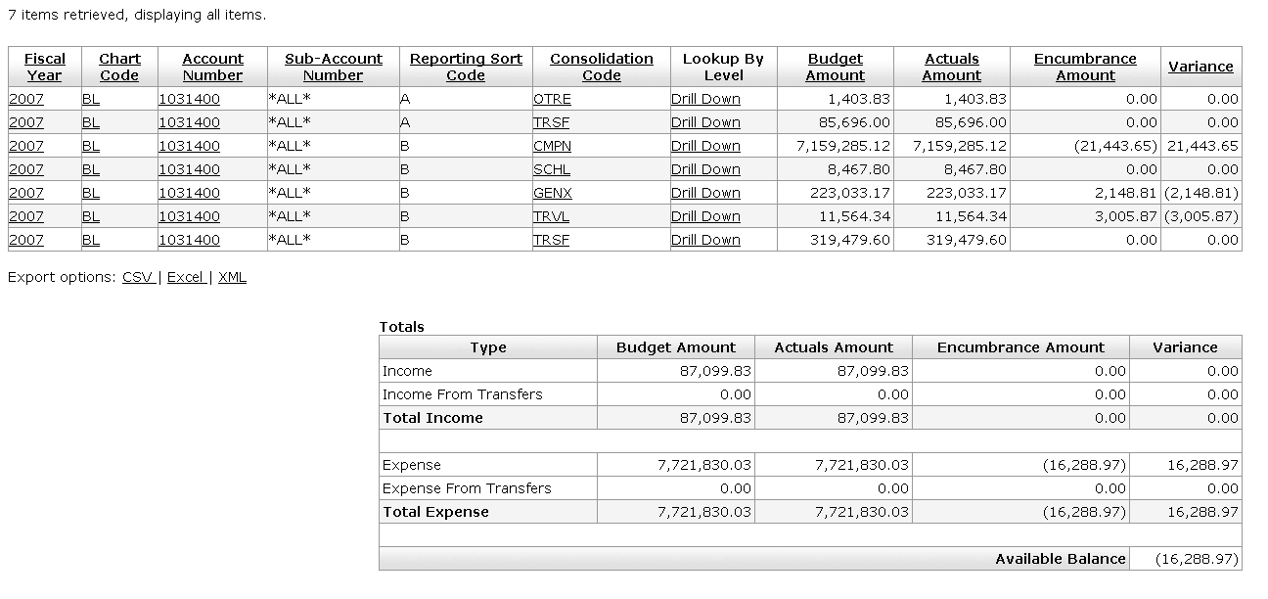
Figure 6-9 Balances by Consolidation Search Result

Balances By Level
Click the Drill Down link to view the balances by Object Code.
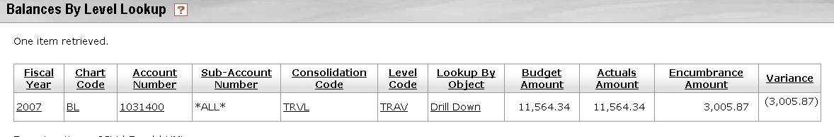
Figure 6-10 Drill Down Link

Balances by Object
Click the hyperlinks for the displayed amount to view the details of the General Ledger Balance.
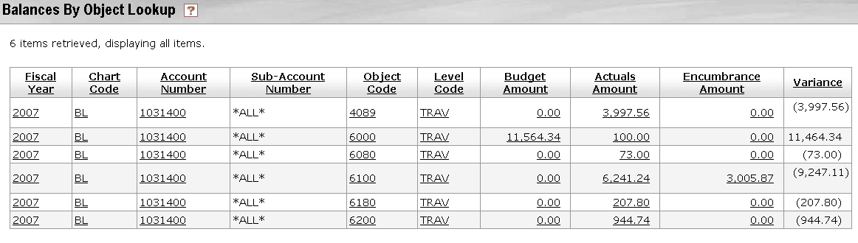
Figure 6-11 Amount Drilldown
For information about the General Ledger Balance, see “General Ledger Balance Inquiry” later in this chapter, page 17.

Cash Balances Inquiry
The Cash Balances inquiry displays the beginning, year-to-date, and available cash balances for an account and/or sub-account. It provides a bottom line snapshot of your account. The report was designed for those accounts that produce income/revenue through sales and services, and cash accounts. In most cases, Fiscal Officers of auxiliary or service accounts or non-budgeted accounts are concerned with their cash balances. However, Fiscal Officers of general fund accounts and some budgeted accounts might not need to use the Cash Balances inquiry.
Choosing the Consolidation option aggregates the amounts by Sub-Account and Sub-Object Code. The Detail option returns balances for each Sub-Account and Sub-Object Code. The Include Pending Ledger Entry option provides the user with the ability to include all cash pending entries, no pending cash entries, or only those pending cash entries that are fully approved. Cancelled and disapproved pending entries are not pulled into the balance inquiry results. There are no drilldown hyperlinks available in this inquiry.
The Cash Balances inquiry should not be confused with the Available Balances inquiry that compares actual transactions and encumbrances to budget amounts.

Lookup Criteria
Fill in at least Fiscal Year, Chart Code and Account Number. Use the lookup icon as necessary to select the criteria. Select the desired Consolidation and Include Pending Ledger Entry options.
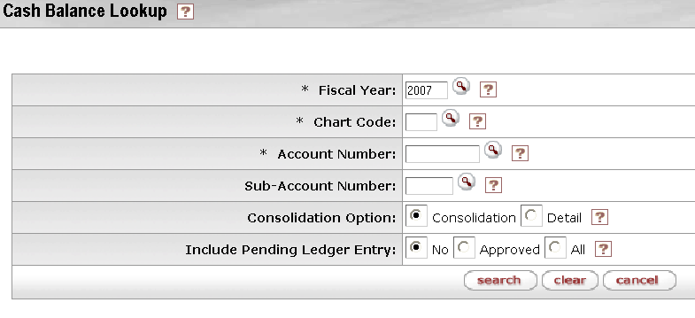
Figure 6-12 Cash Balance Lookup

Cash Balances
Figure 6-13 Cash Balances Inquiry Result

General Ledger Balance Inquiry
The General Ledger Balance inquiry shows an account’s object code balances for each month of the fiscal year. Similar to some of the other KFS online inquiry screens the user can drill down into the balances to view transaction detail and individual e-docs.
Choosing the Consolidation option aggregates the amounts by sub account, sub object code, and object type. The Detail option returns balances for each sub account, sub object code, and object type. The Amount View option lets the user switch between viewing balances for each month (Monthly) and accumulating the balances as you progress through the fiscal year (Accumulate). The Include Pending Ledger Entry option provides the user with the ability to include all pending entries, no pending entries, or only those pending entries that are fully approved. Cancelled and disapproved pending entries are not pulled into the balance inquiry results.
The drilldown pattern of this inquiry is as follows:
1 | General Ledger Balance
2 | General Ledger Entry
3 | E-Doc

Lookup Criteria
Fill in at least Fiscal Year, Chart, Account Number and Balance Type Code. Use the lookup icon as necessary to select the criteria. Select the Consolidation, Amount View, and Include Pending Ledger Entry options.
Choosing the Consolidation option aggregates the amounts by Sub-Account and Sub-Object Code. The Detail option returns balances for each Sub-Account and Sub-Object Code.
The Amount View option gives you a choice to view the amount by monthly amount or accumulated amount.
As with other balance inquiry screens, the Include Pending Ledger Entry option provides the user with the ability to include all pending entries, no pending entries, or only those pending entries that are fully approved. Cancelled and disapproved pending entries are not pulled into the balance inquiry results.
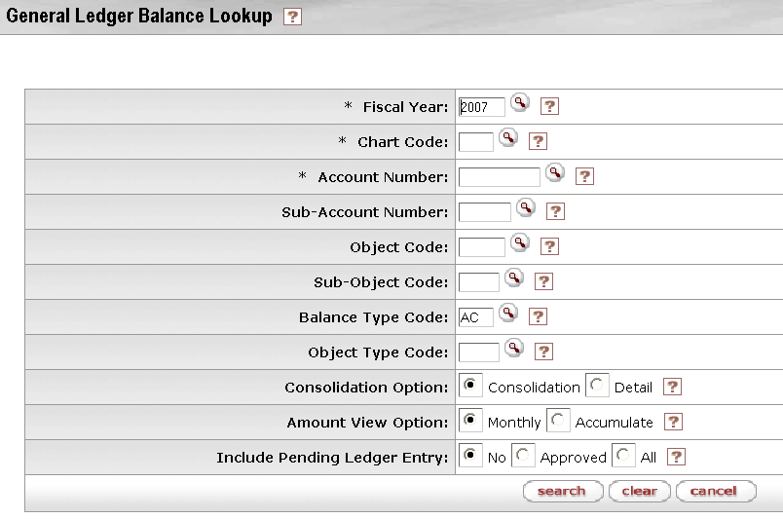
Figure 6-14 General Ledger Balance Lookup

General Ledger Balance
The General Ledger Balance includes the summary balances by Account Number and Object Code followed by monthly transaction amount. You may see the details behind the monthly transaction total amount by clicking the amount hyperlink.
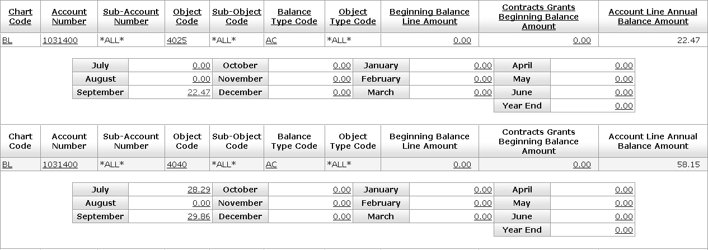
Figure 6-15 General Ledger Balance Inquiry Results
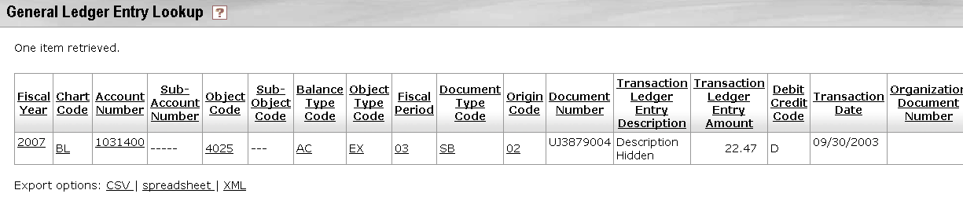
Figure 6-16 When you click the amount hyperlink, another window opens up showing the list of transactions that make up the total monthly amount.
For information about the General Ledger Entry and e-doc drilldown, see “General Ledger Entry” in this chapter, page 22.

View Accumulate Amount
By default, the General Ledger Balance inquiry result displays the distinct amount of activity for each month. However, clicking View Accumulate Amount accumulates the activity by adding all pervious months in the fiscal year to a given month, thus, you are able to view the year-to-date total per month.
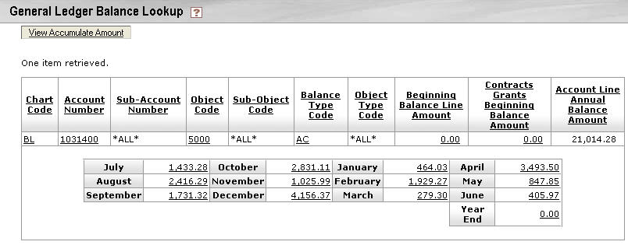
Figure 6-17 Monthly Total Amount
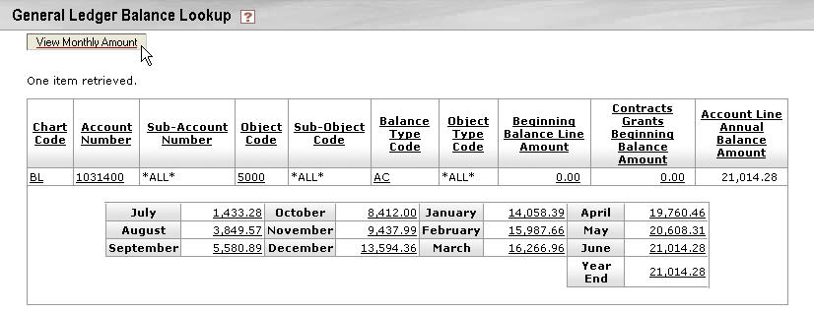
Figure 6-18 Year-to-Date Total by Month

General Ledger Entry Inquiry
The General Ledger Entry inquiry displays the individual transactions that make up the balance in an account. It is the same inquiry that can be displayed by drilling down into the General Ledger Balance report, but instead of drilling down from the General Ledger Balance screen you can go directly to this report by selecting it from the main Balance Inquires menu.
The drilldown pattern of this inquiry is as follows:
1 | General Ledger Entry
2 | E-Doc

Lookup Criteria
Fill in at least Fiscal Year, Chart Code, Account Number, and Fiscal Period. The lookup criteria default to the current Fiscal Year, Balance Type of AC (actuals), and the current fiscal period.
Use the lookup icon as necessary to select the criteria. Select the desired Pending Ledger Entry Approved Indicator option. The Pending General Ledger inquiry offers two alternatives for including the pending ledger entries: the ability to include all pending entries by selecting All or only those pending entries that are fully approved by selecting Approved. Cancelled and disapproved pending entries are not pulled into the balance inquiry results.
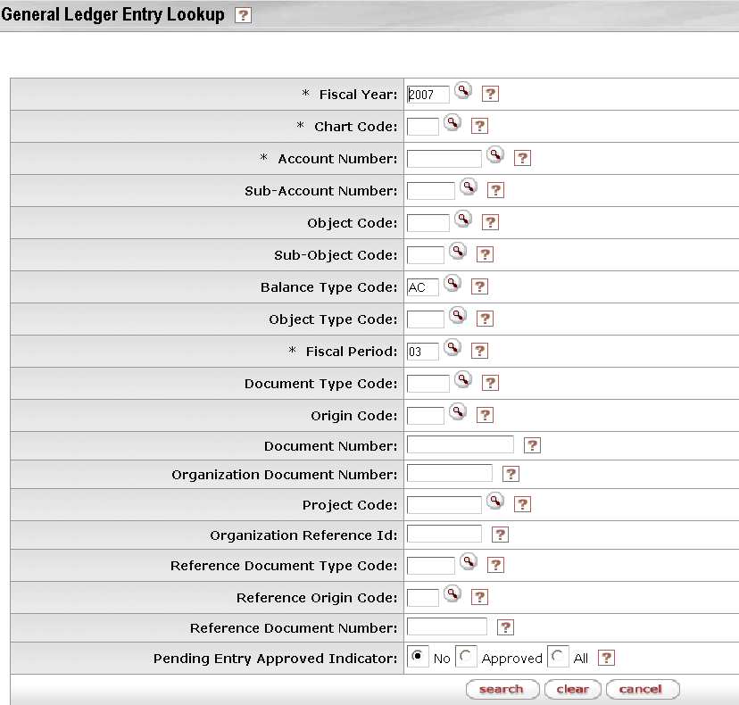
Figure 6-19 General Entry Lookup Criteria

General Ledger Entry
The inquiry results list the transactions that meet your lookup criteria. From here you can drill down into the e-doc that created the transaction.
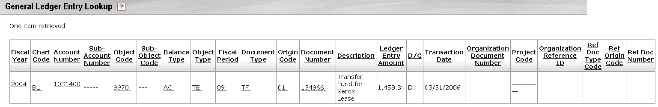
Figure 6-20 General Ledger Entry Inquiry Result

E-Doc Dill-Down
Clicking the document number link from the General Ledger Entry inquiry results allows you to open the underlying e-doc which makes up the transaction. You may view, copy or perform error correction once the document is open, within the constraints of your existing KFS role(s).
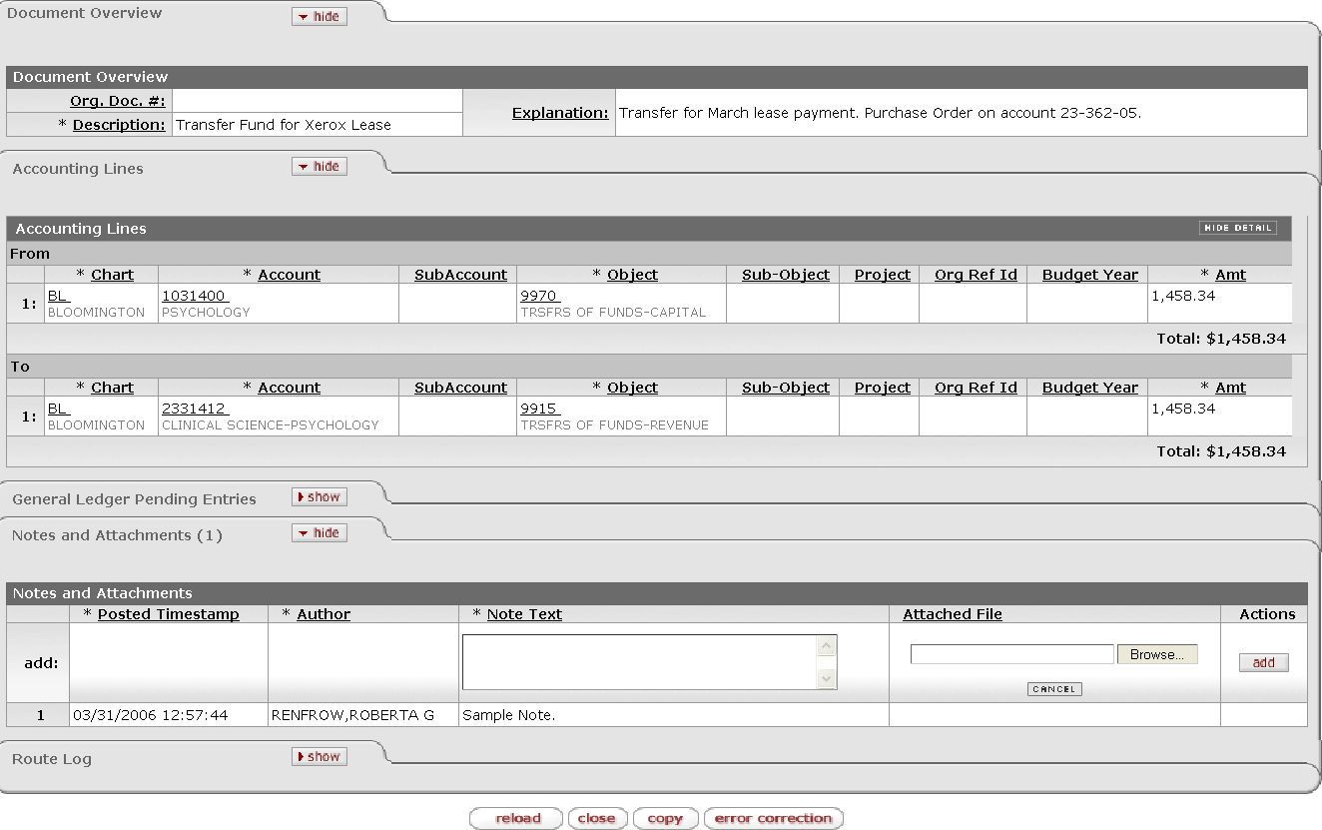
Figure 6-21 You may access the underlying e-doc.

General Ledger Pending Entry Inquiry
The General Ledger Pending Entry Lookup is identical to the General Ledger Entry lookup except that it displays General Ledger Pending Entry transactions. Transactions are pending until the document has made its way completely through the approval process and the G/L batch posting job has run. The drilldown pattern of this inquiry is as follows:
1 | General Ledger Pending Entry
2 | E-Doc

Lookup Criteria
The lookup criteria default to the current Fiscal Year, Balance Type of AC, and the current fiscal period. There are no required criteria for the pending entries lookup. Use the lookup icon as necessary to select the criteria. Select the desired Pending Ledger Entry Approved Indicator option.
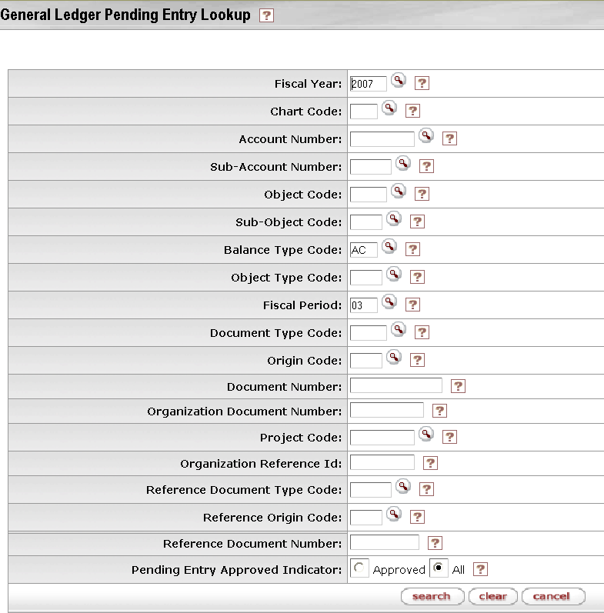
Figure 6-22 General Ledger Pending Entry Lookup

General Ledger Pending Entry
The General Ledger Pending Entry lookup behaves identical to the General Ledger Entry lookup once the initial results are displayed.
For information about the General Ledger Entry, see “General Ledger Entry” in this chapter, page 22.

Open Encumbrances Inquiry
The Open Encumbrances inquiry displays the detail for open encumbrances. At least the fiscal year, chart, and account number must be entered by the user. The valid values you may choose from the encumbrance report include EX (external encumbrances), IE (internal encumbrance), and PE (pre-encumbrance). External encumbrances are those that are set up in an external system such as a purchasing system or travel system. Internal encumbrances are established within the university system, such as encumbrances from a payroll system integrated with the KFS. Pre-encumbrances are established within the KFS via the Pre-encumbrance document. No further drilldown is available in this inquiry.

Inquiry Criteria
Fill in at least Fiscal Year, Chart Code and Account Number. Use the lookup icon as necessary to select the criteria. Select the desired Include Pending Ledger Entry option. The lookup criteria default to the current fiscal year and the Balance Type, EX. To display all encumbrance types, including IE and PE, clear the Balance Type field. Also add:
The Include Pending Ledger Entry option provides the user with the ability to include all pending encumbrance entries, no pending encumbrance entries, or only those pending encumbrance entries that are fully approved. Cancelled and disapproved pending entries are not pulled into the balance inquiry results.
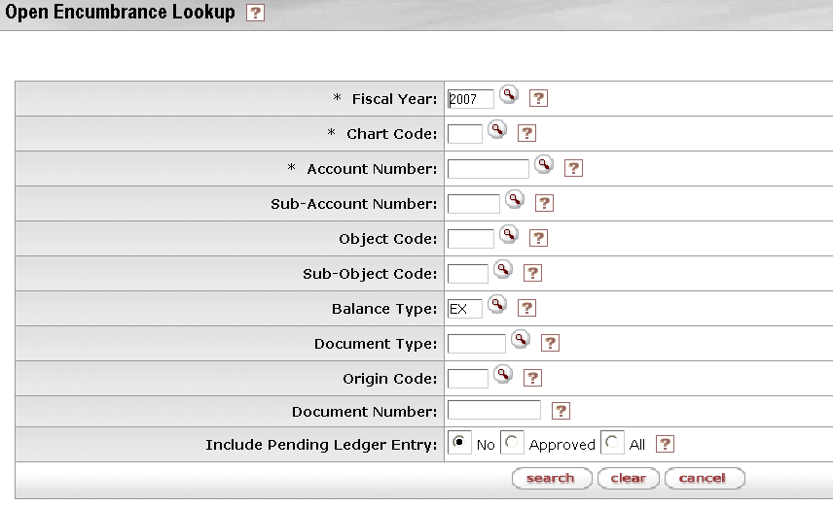
Figure 6-23 Open Encumbrance Lookup Criteria

Open Encumbrances
The system returns a list of open encumbrances. There is no drilldown available from this inquiry.
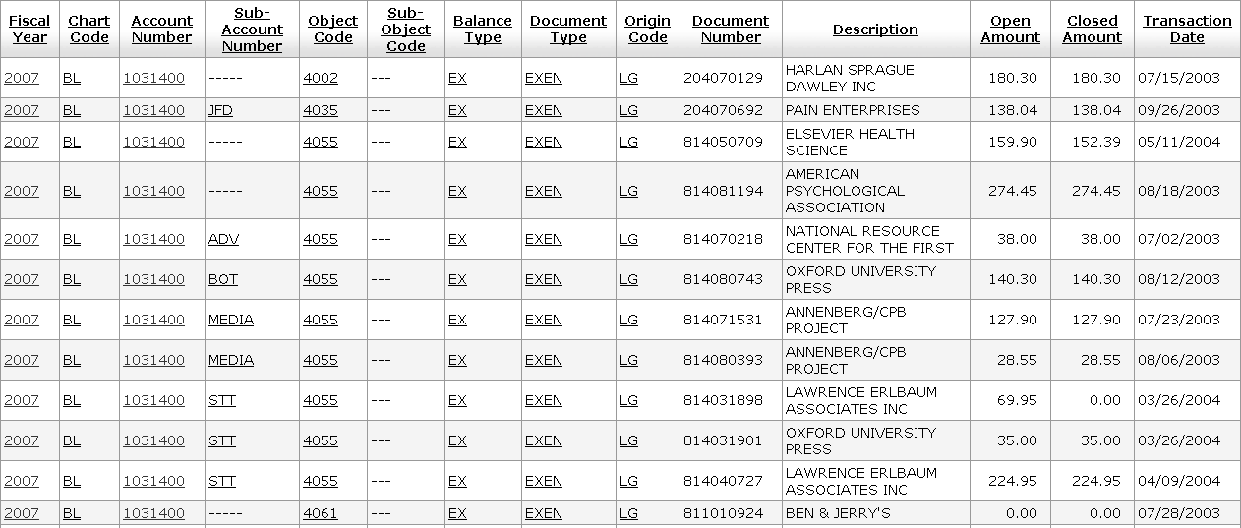
Figure 6-24 Open Encumbrances Inquiry

Standard Reports
The KFS provides a standard set of reports that may be used for monitoring account conditions throughout the year. Included reports are Account Status, Account Transactions, Consolidated Account Status, Consolidated Object Codes and Trial Balance. Standard reports are produced from general ledger and chart modules delivered with the KFS. It is up to each implementing institution to determine the best method for scheduling, running, viewing, and distributing these reports.
Table 6-4 Standard Reports
Report Title | Description
Account Status | Provides summary budget, actual, encumbrance, and projected balances by Account Number and Object Code
Account Transactions | Details the individual transactions shown in summary in the Account Status Report
Consolidated Account Status | Provides summary budget, actual, encumbrance and budget balance totals at the consolidation level for all of the accounts by chart, fund, sub fund, and responsibility center
Consolidated Status | Provides summary budget, actual, encumbrance and budget balance totals at the consolidation level by chart, fund, sub fund, and responsibility center
Trial Balance | Shows beginning fund/net equity balances with additions (revenues and other additions), deductions (expenses and other deductions), and ending cash, asset, liability, and fund balances for each account

Technical Documentation
Refer to KFS Technical Documentation for more information regarding database queries, batch processes and reporting output format possibilities. Report scheduling and archiving functionality is out of scope as of this publication. Other report types falling under the umbrella of KFS Reports, such as Monthly Reports, Operating Statement, Labor Detail, Financial Position, Statement of Activities, Balance Inquiries (through the Kuali Nervous System module) and Ad hoc Reporting generation capabilities are not included in the Phase I delivery of KFS, but are configurable as institution-specific additions to these standard reports.

Standard Report Composition and Interpretation
Standard Reports are made up of three main sections:
- Header Information: The header contains information concerning the identification of the report and management of the account (for example, the name of the Fiscal Officer, organization, responsibility, account number, and the fiscal period of the report).
- Report ID: The report ID is a unique ID assigned to each of the standard reports.
- Column Headings: The column headings identify the contents of the columns directly below them.
- Content: The report is separated into sections identifying the content (or data displayed therein) of each table (for example, tables might include columns for revenues, expenditures, assets, liabilities, fund balances, and rows for subtotals and totals).
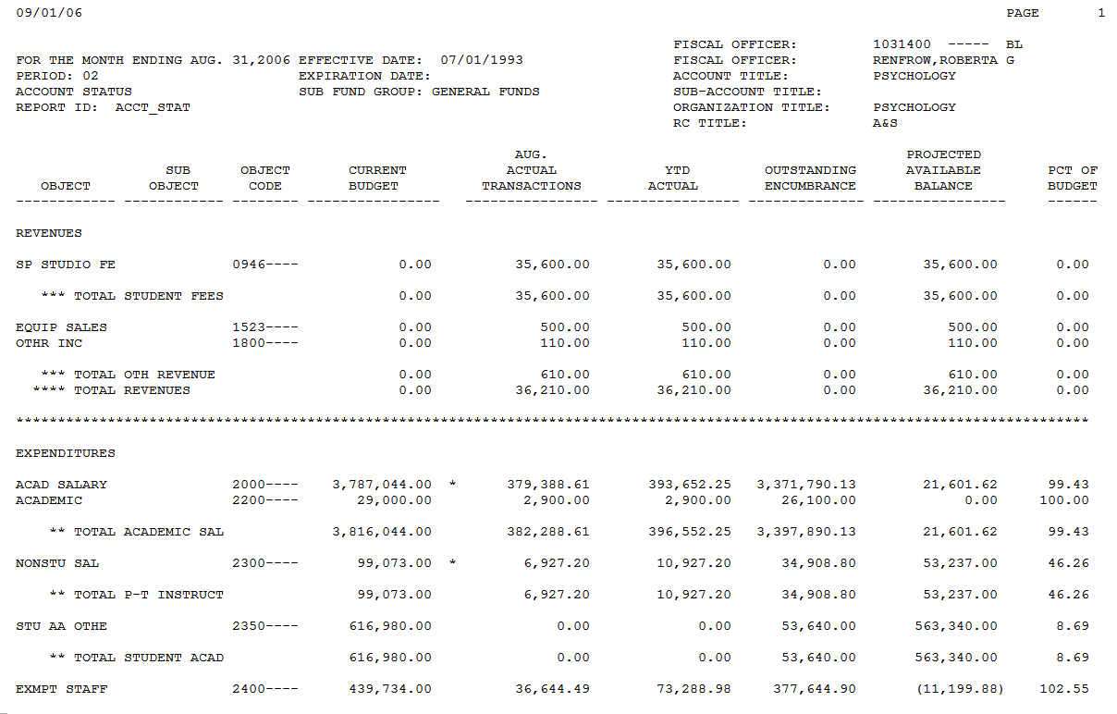
Column headings
Content
Header
Report ID
Figure 6-25 Standard KFS Report Format

Access, Generation and View Process
Depending on the type of report and your institution's configuration, the report can be viewed, printed, and saved for your records and future reference. The native format (indicated by corresponding file extension) of the report may be viewable with compatible software, such as Text (.TXT), Portable Document Format (.PDF), MS Word (.DOC), MS Excel (.XLS) or Comma Separated Values (.CSV).

Account Status Report
The Account Status report provides summary balances by Account Number and Object Code. The budget, actual, and encumbrance totals are provided for the fiscal period shown on the report.
Figure 6-26 Account Status Report

For Accounts/Object Codes with Budgets
The report shows Budget, Actual to Date, Balance, Commitments, and Final Balance.

For General Ledger Accounts and/or Object Codes
- The report shows Beginning Balances, Actual to Date and Ending Balances for each object code for assets, liabilities, fund balances/net equities and cash ownership.

Account Transactions Report
The Account Transaction report provides the details of the individual transactions shown in summary in the Account Status report. The transactions include actual, budget, and outstanding encumbrances (internal, external and pre-encumbrances).
The report features the following:
- Transaction descriptions and document references are included.
- Object code totals are shown consistent with the Account Status report.
- There are separate sections for actual and commitment activity
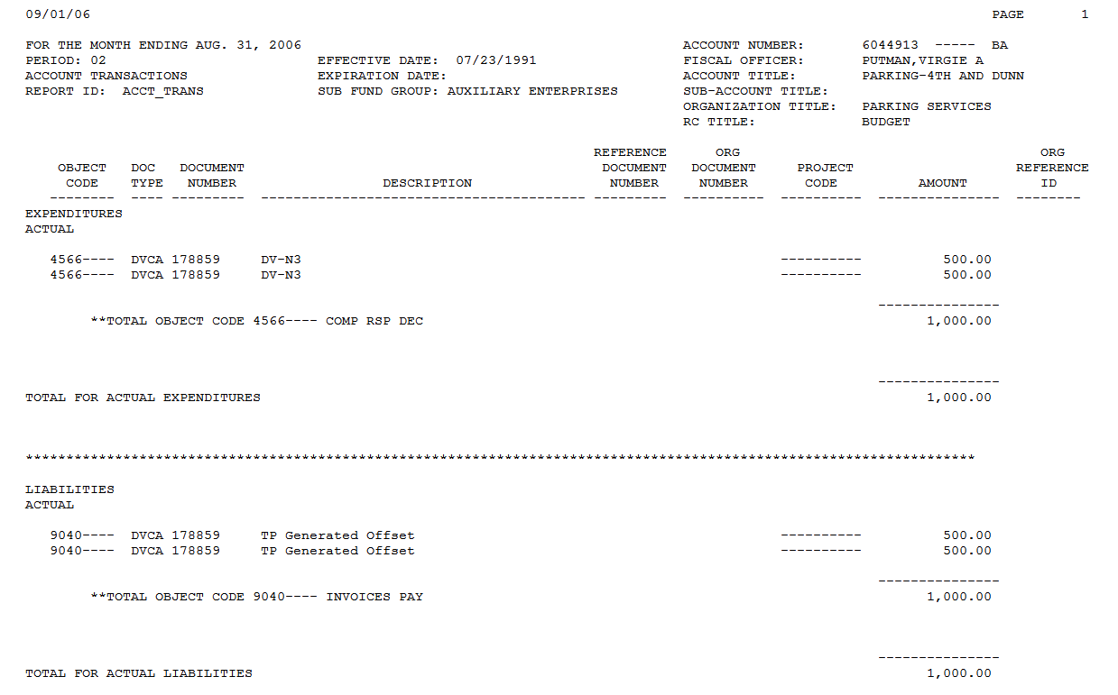
Figure 6-27 Account Transactions Report

Consolidated Account Status Report
The Consolidated Account Status report groups all accounts for a given chart, fund, sub fund, and responsibility center. The format is somewhat similar to the Account Status Report, discussed earlier in this chapter. Current budget, year-to-date actual, open encumbrance, and a remaining budget balance amounts are displayed at the consolidation level for each account.
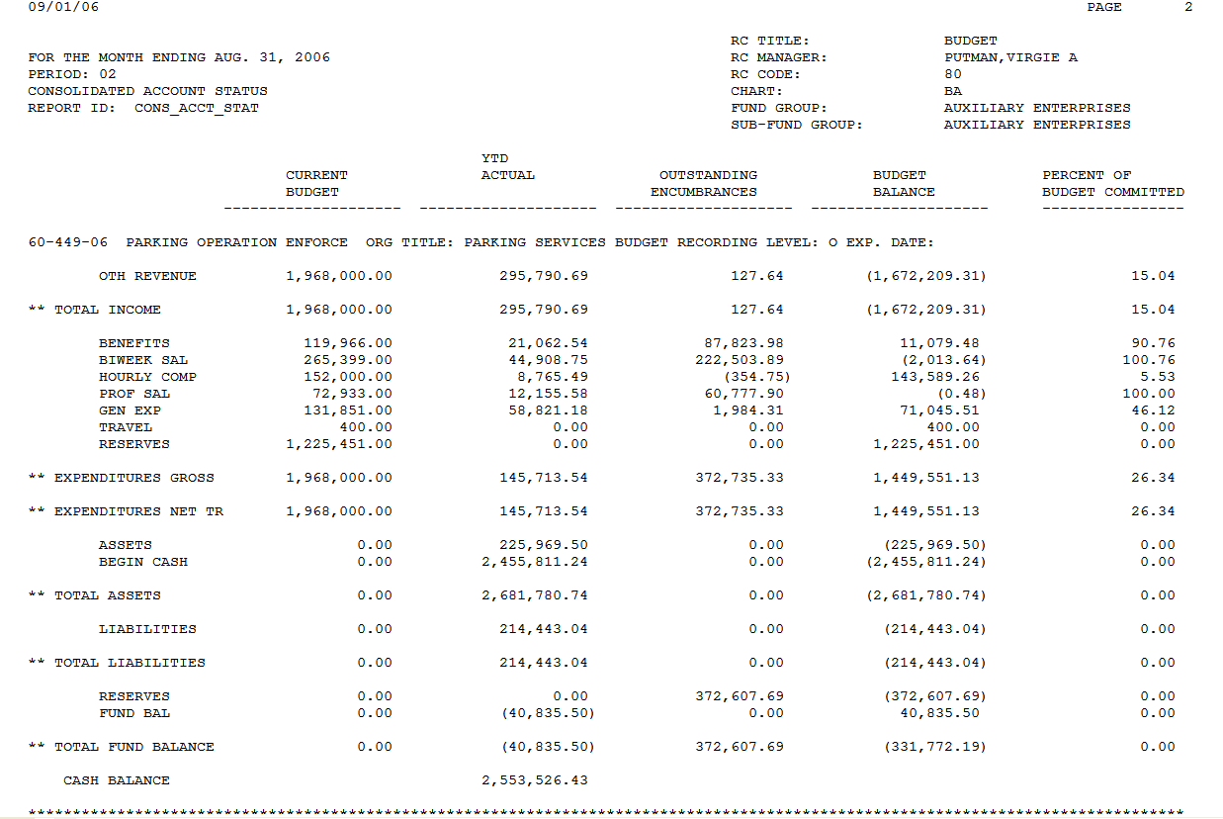
Figure 6-28 Consolidated Account Status Report

Consolidated Status Report
The Consolidated Status report shows summary budget, actual, encumbrance and budget balance totals at the consolidation level for each chart, fund, sub fund, and responsibility center. The format is the same as the Consolidated Account Status report except that individual account numbers are not displayed.
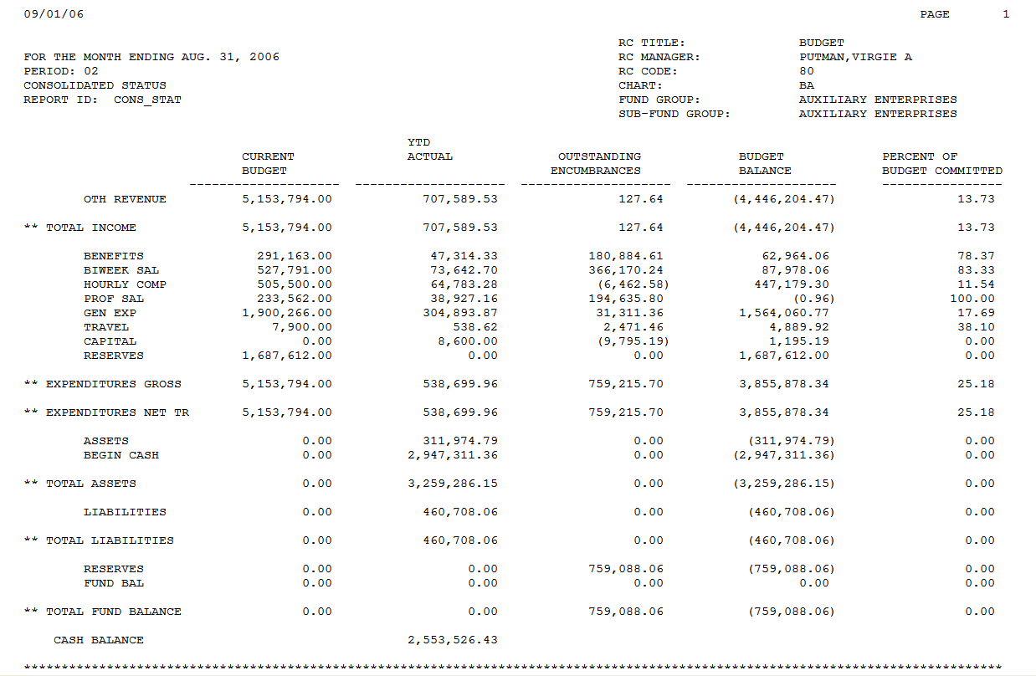
Figure 6-29 Consolidated Status Report

Trial Balance Report
The Trial Balance report combines beginning fund/net equity balances with additions (revenues and other additions), deductions (expenses and other deductions) and ending balance for each account.
Columns for assets and liabilities and cash ownership to complete the accounting equation are also available.
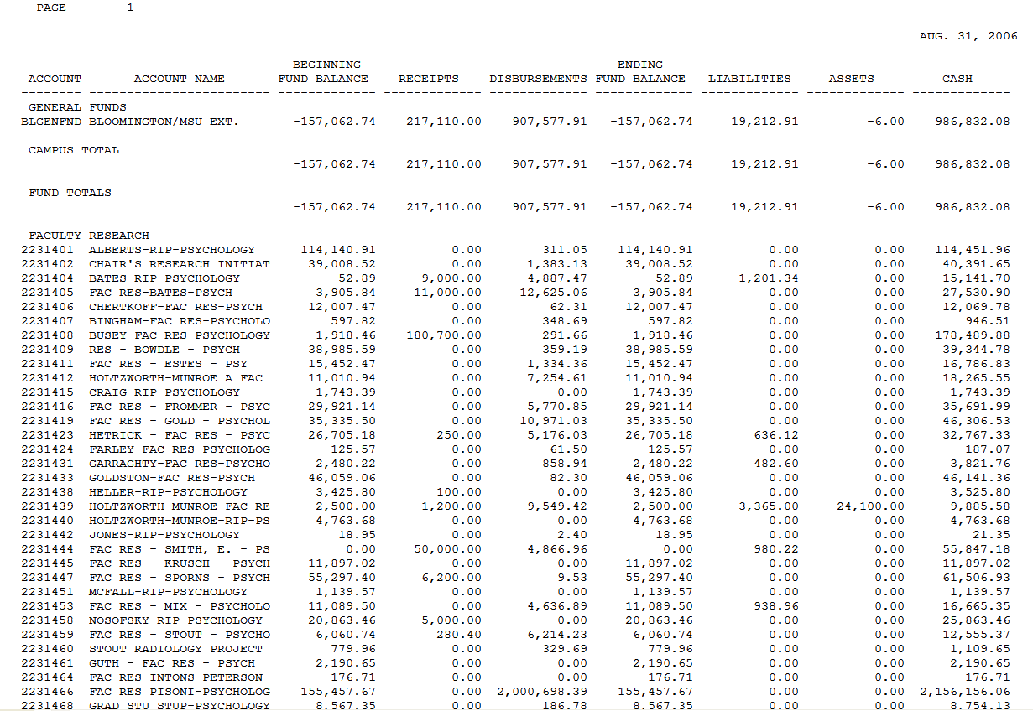
Figure 6-30 Trial Balance Report

Summary
In this chapter, you were introduced to the KFS on-line balance inquiries and standard reports for your decision support. The on-line balance inquiries include Available Balances, Balances by Consolidation, Cash Balances, General Ledger Balance, General Ledger Entry, General Ledger Pending Entry, and Open Encumbrances inquiries. The standard on-line reports include Account Status, Account Transactions, Consolidated Account Status, Consolidated Status, and Trial Balance reports.

